Contents

Nodes 2

1. What kind of information does Nodes exactly hold in order to make ETH possible? 2

UTXO vs Account Model 2

# Nodes

## What kind of information does Nodes exactly hold in order to make ETH possible?

In Bitcoin nodes have full version of blockchain so they have all the information and in the blockchain they have all the transactions that have happened.

In ETH they have smart contracts, blockchain now has all transactions and transactions look a bit different from bitcoin but still you have all the records of transactions in the blockchain. Then you have the codes for all smart contracts, mostly byte codes.

And then you have states of all Smart Contracts.

s1 = states

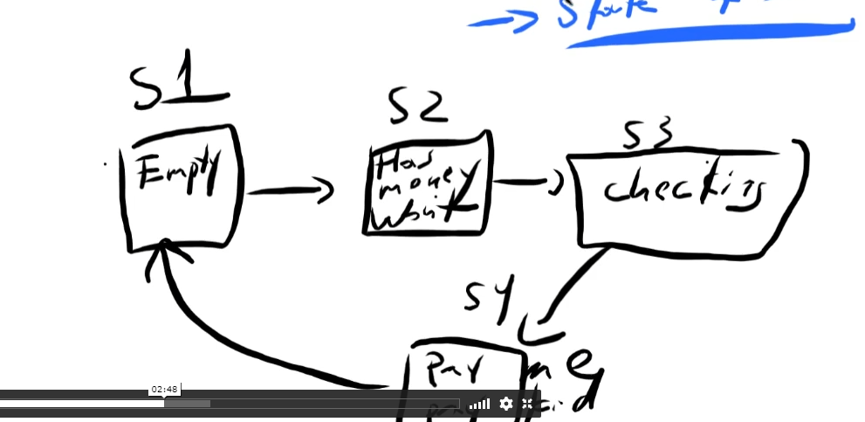

# UTXO vs Account Model

When your wallet finds the sum of your money, it will search all the UTXO (Unspent Transactions) that you can spend. It is unlike bank account where it shows you balance, here in wallet it shows you only UTXO and then you add altogether and gets you wallet.

In ETH you have a balance, in ETH blockchain will store all of your transactions but at the same time you do not have UTXO models, each transaction updates accounts.

For example, If I have a 5 ETH on my balance and if was sending to someone, the transaction would now just update my account balance. So if I send 1 ETH to somebody, my balance of ETH would now be 4 ETH. It just switches numbers. There is no use of UTXOs, transaction of ETH does not have inputs and outputs, it just have ‘move funds from this acc to another acc’ and it just updates the numbers in the Database (blockchain).

This ETH transactions take less space because it is way easier to tell move 1 btc from a to b compared to multiple outputs. It is simpler and at the same time it is less private because there is no way to send money back to myself or give myself a change.

So, from outside anyone viewing the blockchain you can see how much money you sent and to which address that which received it.

In BTC you can transact money to someone and some money back to me in a single transaction and from outside it is impossible to know which is which, which money went to who, or maybe both moneys went to you.

This is why ETH privacy is bit lacking.

But in the Account model in ETH have balance of each account. It is bit more fungible, you can

Fungible (easy to exchange or trade for something else of the same type and value)

Fungible

1 ETH = 1 ETH

Non fungible

1 btc != 1 btc

BTC is non-fungible because if you check all the UTXO history, it could potentially have bad records such as robbery or anything bad events.

